How to setup a scheduler Locally on Windows Machine

Go to Control Panel\All Control Panel Items\Administrative Tools

Click on Task Scheduler Icon

Right click on Task Scheduler Library and create New Folder

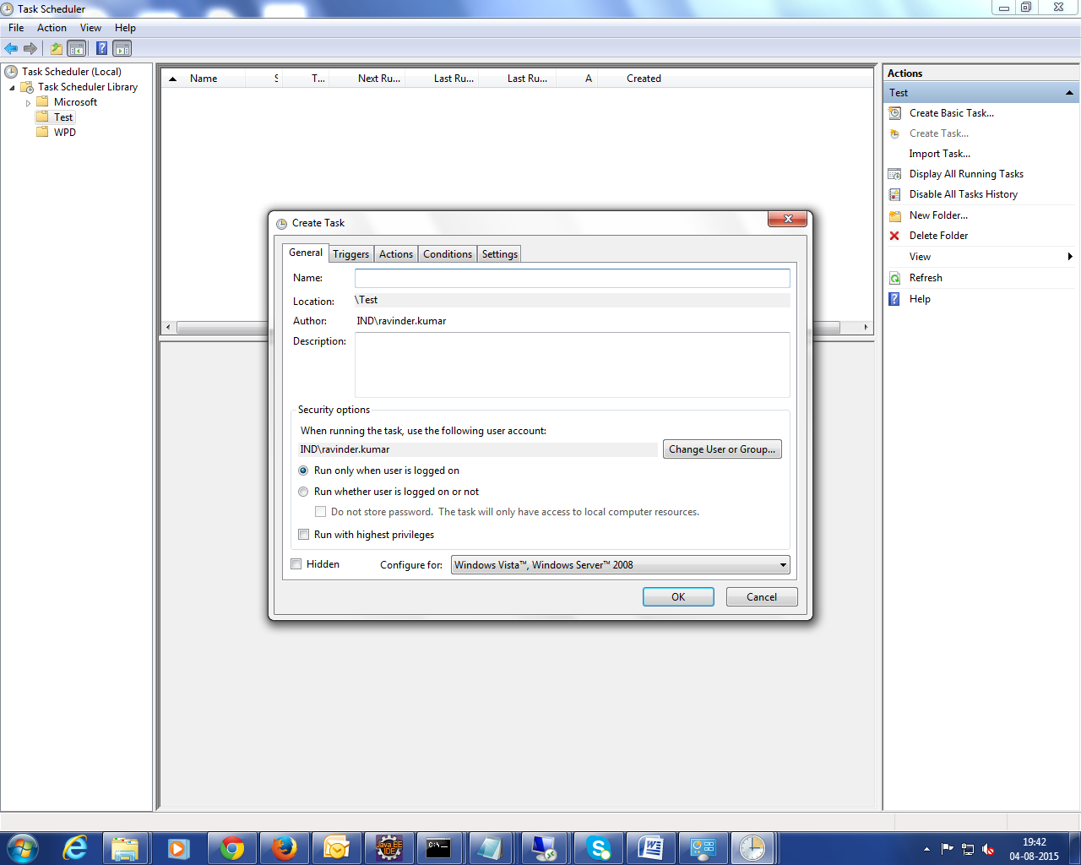

Right Click on Created Folder and click on create Task and Go to General Tab

Enter Name Test or any other and after that go to actions tab and browse the location of bat file.

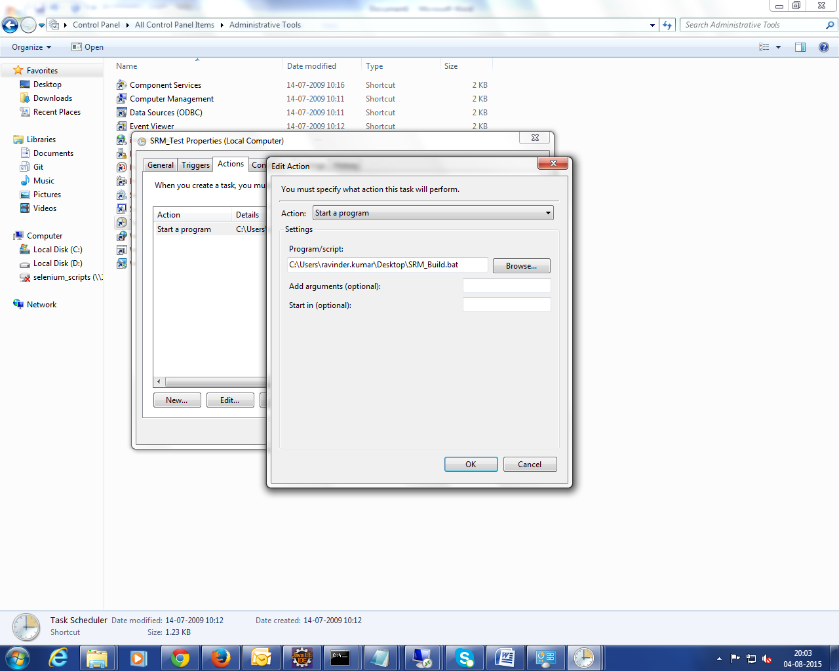

Click on Triggers and schedule the job on it.

------------------------------How to setup a scheduler on Remote machine--------------------

Go to Control Panel\Scheduled Tasks

Right click mouse and New ->Schedule Tasks

Select the path of batch files location after clicking on browse button in task tab section.

Batch File path \\10.78.7.60\selenium_scripts\Webdriver2.0\SeleniumHubandNodes\SRM\SRM_Dev.bat

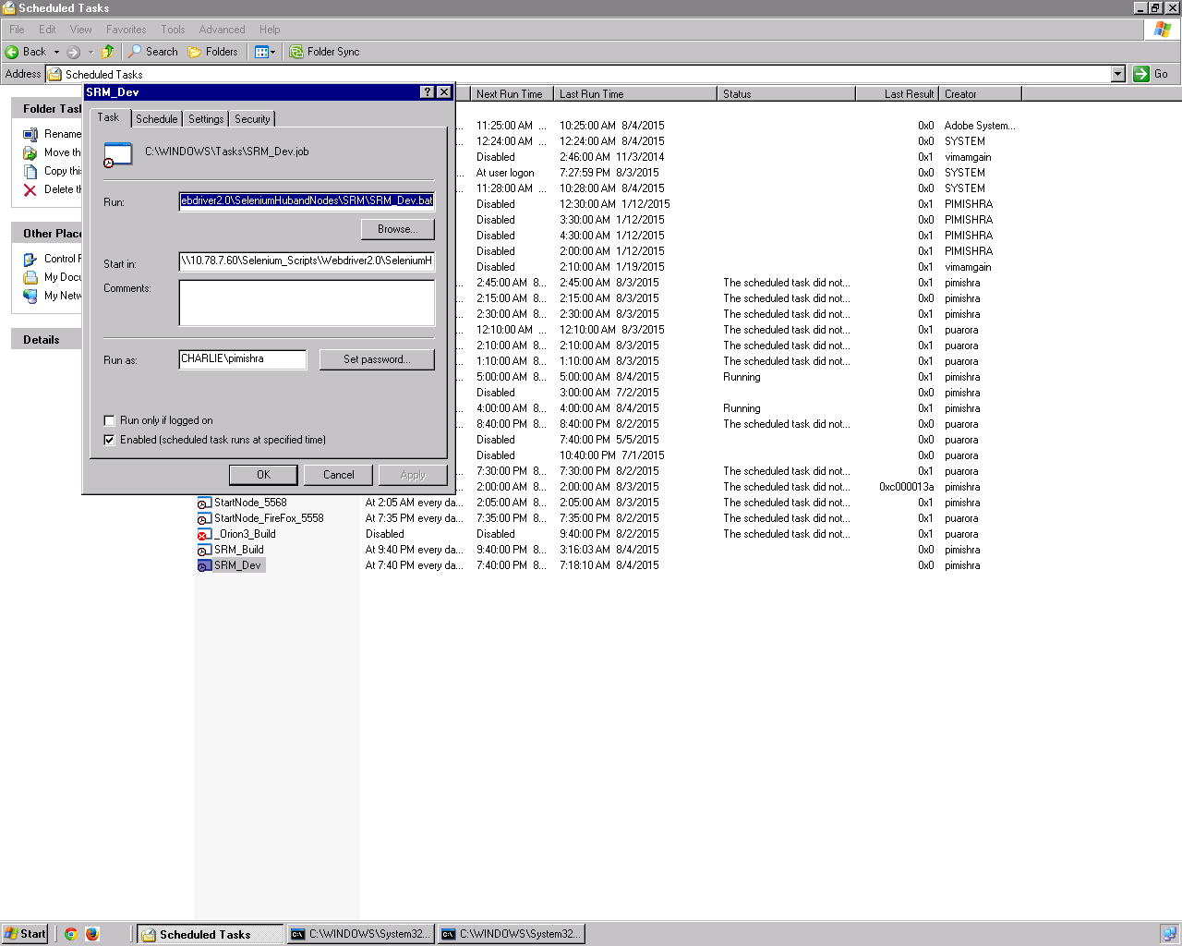

And enter text in start in filed upto \\10.78.7.60\Selenium_Scripts\Webdriver2.0\SeleniumHubandNodes\SRM

And click on enabled check box